**I2C Core**

**Core Overview**

I2C Core 可以使 FPGA 内部逻辑与外部器件通过 I2C 接口串行通信, I2C Core 提供了一个 Avalon Memory-Mapped (Avalon-MM) 从端口来允许 Avalon-MM 主端口设备(如 Nios II 处理器) 通过简单的读写控制和数据寄存器来与 IP 核沟通.

**Functional Description**

I2C Core 包含两个用户可见的端口:

* Avalon-MM Slave 接口, 可以通过该端口访问寄存器
* I2C 接口, 包括 SCL 和 SDA 信号

**Configuration**

**I2C Clock (SCL) Rate**

I2C Core 同步于提供给 Avalon-MM 接口的时钟. I2C 接口的 SCL 输出时钟由该时钟分频而来. 模块的输入时钟需要用户给定, 并且与实际所接的时钟频率一致.

I2C 的输出时钟频率为 0~3400kHz. 输入的时钟频率至少为输出频率的 4 倍. 如果输入频率不是输出频率的整数倍, SCL 的实际频率可能跟设定的目标频率不完全相同.

**Software Programming Model**

**Software Files**

I2C Core 提供了以下软件文件, 这些文件提供了硬件的底层接口.

* **i2c_avalon_driver.h**—这个文件提供了访问底层硬件的函数定义.
* **i2c_avalon_driver.c**—这个文件包含访问底层硬件函数的实现.

**Register Map**

**Table 1-1: Register Map for I2C Core**

|  |  |  |  |  |  |  |
| --- | --- | --- | --- | --- | --- | --- |
| Internal Address | Register Name | Type [R/W] | 31..8 | 7..2 | 1 | 0 |
| 0 | control/state | R/W |  | | ACK | START/ $\overline{\text{STOP}}$ |
| 1 | txdata | W |  | TXDATA | | |
| 2 | rxdata _ack | R |  | RXDATA | | |
| 3 | rxdata _nack | R |  | RXDATA | | |

读取未定义的位会返回不确定的值. 向未定义的位写没有效果.

**control/state Register**

当向该地址进行写操作时为控制寄存器, 对该地址进行读操作时为状态寄存器.

控制寄存器: Bit0 为起始/停止位, 其他位都没有使用, 向该位写 1 会在 I2C 总线上发起开始操作, 向该为写 0 会在 I2C 总线上发起停止操作.

控制寄存器: Bit1为 ACK 标志位, 其他位都没有使用, ACK标志位会在每次进行完 I2C 写操作后更新, 读取该位会返回上一次的 ACK 结果.

**txdata Register**

向该地址写入的数据会发送到 I2C 数据总线上, 并在每次发送完成以后读取 ACK 状态并更新相应的寄存器.

**rxdata_ack Register**

读取该寄存器会在 I2C 总线上发起读操作, 并在读操作完成以后自动发送一个 ACK 标志, 并把读取到的数据返回.

**rxdata_nack Register**

与上一个寄存器类似, 读取该寄存器会在 I2C 总线上发起一个读操作, 但在读取完成之后会自动发送一个 NACK 标志, 并把读取到的读数据返回.

**Software Function Introduction**

**i2c_start()**

|  |  |
| --- | --- |
| Prototype: | void i2c_start(unsigned int base) |
| Include: | < i2c_avalon_driver.h> |
| Description: | 调用该函数会在 I2C 总线上发起开始操作. |
| Returns: | No. |

**i2c_stop()**

|  |  |
| --- | --- |
| Prototype: | void i2c_stop(unsigned int base) |
| Include: | < i2c_avalon_driver.h> |
| Description: | 调用该函数会在 I2C 总线上发起停止操作. |
| Returns: | No. |

**i2c_get_ack ()**

|  |  |
| --- | --- |
| Prototype: | unsigned char i2c_get_ack(unsigned int base); |
| Include: | < i2c_avalon_driver.h> |
| Description: | 通过该函数读取 ACK 寄存器的值. |
| Returns: | 0 代表 ACK, 1 代表 NACK. |

**i2c_write ()**

|  |  |
| --- | --- |
| Prototype: | void i2c_write(unsigned int base,  unsigned char data) |
| Include: | < i2c_avalon_driver.h> |
| Description: | 向 I2C 总线上写 1Byte 数据, 并读取 ACK 的值. |
| Returns: | No. |

**i2c_read_with_ack ()**

|  |  |
| --- | --- |
| Prototype: | unsigned char i2c_read_with_ack(unsigned int base) |
| Include: | < i2c_avalon_driver.h> |
| Description: | 从 I2C 总线上读取 1Byte 数据, 并发送一个 ACK 信号. |
| Returns: | 读取到的 1Byte 数据. |

**i2c_read_with_nack ()**

|  |  |
| --- | --- |
| Prototype: | unsigned char i2c_read_with_nack(unsigned int base) |
| Include: | < i2c_avalon_driver.h> |
| Description: | 从 I2C 总线上读取 1Byte 数据, 并发送一个 NACK 信号. |
| Returns: | 读取到的 1Byte 数据. |

**Example**

**Example 1**

**LM92: Typical Pointer Set Followed by Immediate Read for 2-Byte Register**

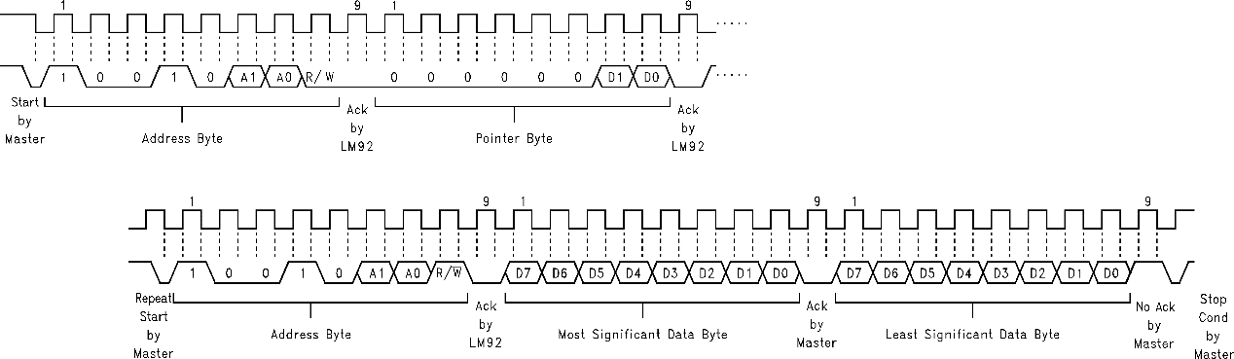

|  |
| --- |
| #include "system.h"  #include <i2c_avalon_driver.h>  int main()  {  unsigned char ack[3];  unsigned char ans[2];  i2c_start(I2C_AVALON_BASE); //Start by Master  i2c_write(I2C_AVALON_BASE,0x90); //Address Byte  ack[0] = i2c_get_ack(I2C_AVALON_BASE); //Get Ack by LM92  i2c_write(I2C_AVALON_BASE,0x00); //Pointer Byte  ack[1] = i2c_get_ack(I2C_AVALON_BASE); //Get Ack by LM92    i2c_start(I2C_AVALON_BASE); //Repeat Start by Master  i2c_write(I2C_AVALON_BASE,0x91); //Address Byte  ack[2] = i2c_get_ack(I2C_AVALON_BASE); //Get Ack by LM92  ans[1] = i2c_read_with_ack(I2C_AVALON_BASE); //Data MSB with Ack  ans[0] = i2c_read_with_nack(I2C_AVALON_BASE); //Data LSB with No Ack  i2c_stop(I2C_AVALON_BASE); //Stop Cond by Master  return 0;  } |

**Example 2**

**LM92: Typical 1-Byte Read from Configuration Register with Preset Pointer**

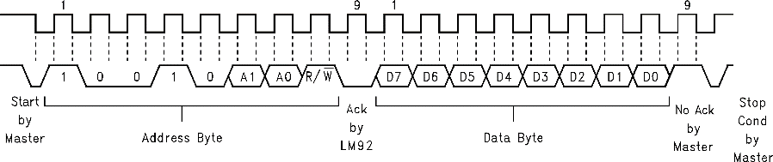

|  |
| --- |
| #include "system.h"  #include <i2c_avalon_driver.h>  int main()  {  unsigned char ans;  i2c_start(I2C_AVALON_BASE); //Start by Master  i2c_write(I2C_AVALON_BASE,0x91); //Address Byte  ans = i2c_read_with_nack(I2C_AVALON_BASE); //Data Byte  i2c_stop(I2C_AVALON_BASE); //Stop Cond by Master  return 0;  } |

**Document Revision History**

|  |  |  |
| --- | --- | --- |
| Data | Version | Changes |
| August 2015 | 1.1 | 重写了核心代码, 提高了兼容性. |
| August 2015 | 1.0 | 第一次发布 |